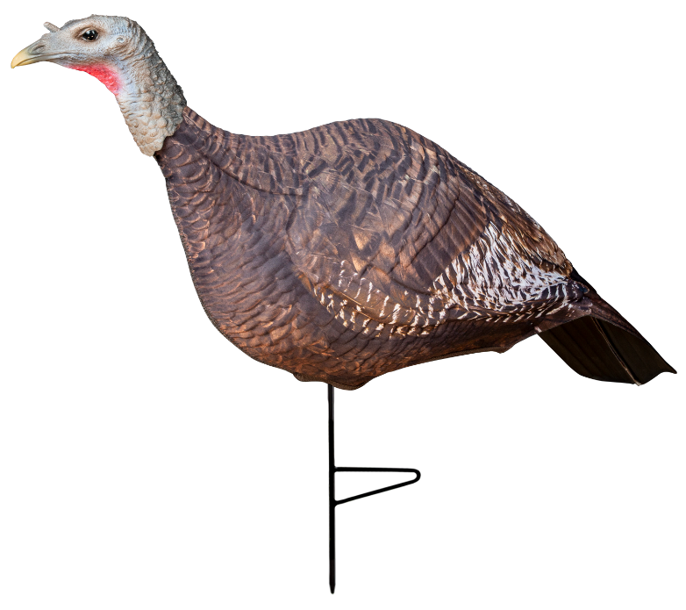
Primos Photoform Hen Decoy

SKU | NAME | UPC | AVG RETAIL
69068 | Primos Photoform Hen Decoy | 0-10135-69068-7 | $69.99
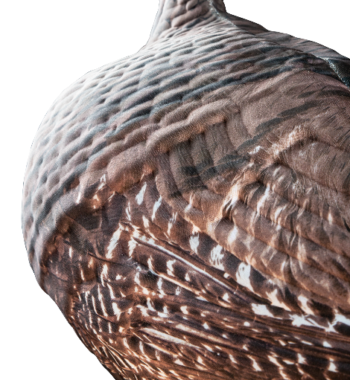
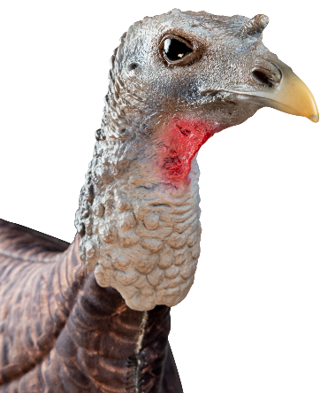
The most realistic decoy on the market! The Primos Photoform Hen Decoy utilizes a proprietary process that allows us to take actual imagery of a hen and print it on 3D molded foam. Not only will this decoy be light enough to carry around all day but it will also allow you to collapse it down to fit right in your vest. Never worry about lugging your overweight decoys around the turkey woods again with this new decoy.

- Proprietary Photoform process using actual imagery of a turkey
- Extremely lightweight, flexible and portable
- Multiple positions; contented, feeding and breeding

